Be prepared for winter
Communications toolkit
October/November 2024

Introduction
‘Be Prepared for Winter’ is the first stage of our local system winter campaign, designed to empower individuals and communities to take proactive steps to safeguard their health and wellbeing during the winter months. By encouraging specific actions, we aim to reduce the strain on NHS services during this challenging season. This toolkit is provided to help our partners effectively share key messages and resources across their networks and channels.

Key aims
- Promote vaccination uptake: Encourage those eligible to get their flu, COVID-19, and RSV vaccinations.
- Encourage self-care practices: Highlight the importance of having a well-stocked medicine cupboard at home and signposting community self-referral tools for winter support and advice.
- Promote the use of Pharmacy First: Educate individuals on accessing their local pharmacy for minor ailments and advice.
- Support mental health: Provide advice on maintaining mental wellbeing during the winter months.
- Boost immunity: Encourage healthy eating, drinking, and regular physical activity.
- Prevent falls: Share practical advice to reduce the risk of falls, particularly among older adults.

Key messages

- Vaccination uptake
  - Get vaccinated, stay protected: Winter is a high-risk time for illnesses like flu, COVID-19, and RSV. Vaccinations are a simple, effective way to protect yourself and others.
    - The RSV vaccine is new for 2024 and helps protect against respiratory syncytial virus (RSV), a common virus that can make babies and older adults seriously ill. It is recommended during pregnancy and for adults aged 75 to 79.
  - Check your eligibility: If you are eligible, make sure to book your flu, COVID-19, and RSV vaccinations as soon as possible. These vaccines are especially important for older adults, those with underlying health conditions, and pregnant women. Visit the Hertfordshire and west Essex vaccination hub for more information on all seasonal vaccinations, eligibility criteria and how to get your vaccine. https://www.hertsandwestessex.ics.nhs.uk/your-health-and-care/vaccinations/
- Self-care practices
  - Be prepared at home: Ensure your medicine cupboard is stocked with essentials like pain relief, cold and flu remedies, and any regular medications you may need. You can seek advice from your local pharmacy on these medicines.
  - Use community referral tools to help guide you: Both in Essex Essex Frontline and in Hertfordshire HertsHelp can help connect you with vital support services in your local community. Whether you need help with staying warm, managing energy bills, or accessing food and healthcare, they are ready to guide you.
- Pharmacy First
  - Your pharmacist can help: Using your local pharmacy can help you get the free NHS care you need quickly. Most pharmacies can also offer prescription medicine for some conditions, without you needing to see a GP or make an appointment. This is called Pharmacy First. The service includes the supply of appropriate medicines for 7 common conditions aiming to address health issues before they get worse. Conditions they can offer prescription medicine for are:
        - impetigo (aged 1 year and over)
        - infected insect bites (aged 1 year and over)
        - earache (aged 1 to 17 years)
        - sore throat (aged 5 years and over)
        - sinusitis (aged 12 years and over)
        - urinary tract infections (UTIs) (women aged 16 to 64 years)
        - shingles (aged 18 years and over)
  - Visit https://www.hertsandwestessex.ics.nhs.uk/your-health-and-care/support/pharmacy/ for more information.
  - Community pharmacies offer a more convenient way to access healthcare that includes support with healthy eating, exercise, stopping smoking, monitoring your blood pressure, contraception, flu and covid vaccinations.
  - Save time and stay well: if you need help with a health concern NHS 111 online can help refer you to appropriate support including provide an appointment with a pharmacist. Pharmacists are trained professionals who can offer advice and treatment on a range of common conditions. If 111 refers you to a pharmacist that is the best place for your needs and you would get the same treatment that you would if seen elsewhere.

- Mental health and wellbeing
  - Look after your mental health: Winter can be tough on mental wellbeing. Take time to check in with yourself and loved ones. Simple actions like staying connected with others, maintaining a routine, and getting outside during daylight hours can make a big difference. Dedicated information for looking after your mental wellbeing can be found here: https://www.hertsandwestessex.ics.nhs.uk/your-health-and-care/stay-well/winter-health-and-wellbeing-hub/managing-your-mental-health-during-the-colder-months/
  - Seek support if needed: If you are struggling with your mental health, do not hesitate to reach out for help. There are many resources available, including NHS 111 (option 2), your GP practice, local mental health services, and helplines.
- Boosting immunity
  - Eat well, stay active: A balanced diet and regular physical activity are crucial for maintaining a strong immune system. Even in colder weather, try to incorporate fruits, vegetables, and exercise into your daily routine.
  - Stay hydrated: Drinking enough water is essential, even in winter. It helps your body function optimally and can prevent dehydration, which can weaken your immune system.
- Falls prevention
  - Keep your home safe: To prevent falls, especially in older adults, ensure homes are free from trip hazards, well-lit, and have non-slip mats in potentially slippery areas like bathrooms.
  - Stay active to stay steady: Regular exercise, particularly activities that improve balance and strength, can significantly reduce the risk of falls.
  - Further information on preventing falls can be found on the NHS website
Key call to action: Refer to the Winter Information Hub
For more detailed information and resources on how to stay healthy and safe this winter, please refer people to visit the Hertfordshire and west Essex winter health and wellbeing hub at www.hertsandwestessex.ics.nhs.uk/winter
The hub serves as a central source of information, offering the latest updates, advice, and guidance on vaccinations, self-care, mental health, and other winter-related health matters. By directing individuals to this resource, we ensure they receive consistent and accurate information.

Communication channels and tactics
Social media: Use platforms like Facebook, X and Next Door to share key messages, tips, and reminders, directing people to the Winter health and wellbeing hub. We have provided ready-made posts and graphics that can be scheduled throughout the winter season.
Email newsletters: Incorporate campaign messages into your existing newsletters with a prominent link to the winter hub. Short, actionable advice pieces are ideal for this format.
Digital display: Display posters in key community locations such as GP surgeries, pharmacies, libraries, and community centres. Ensure all materials include the link to the winter health and wellbeing hub.

Community Engagement: Partner with local organisations, such as community groups, faith organisations, and schools, to reach wider audiences. Community events, workshops, or talks can be effective ways to engage people in the campaign, with all materials pointing to the winter health and wellbeing hub.

Internal communications messaging
‘Be Prepared for Winter’
As we approach the winter months, it is crucial that we all take steps to protect our health and wellbeing, as well as support the wider community in doing the same. The NHS Hertfordshire and west Essex Be Prepared for Winter campaign is now underway, and we are encouraging everyone to familiarise themselves with the key messages and resources available.
Key campaign focus areas:
- Vaccinations: Ensure eligible individuals are informed about the importance of flu, COVID-19, and RSV vaccinations.
- Self-Care: Encourage the community to keep a well-stocked medicine cupboard and know how to treat minor ailments at home.
- Pharmacy First: Promote the use of local pharmacies for minor health issues to reduce pressure on GP services and A&E.
- Mental Health: Share advice on maintaining mental well-being during the colder, darker months.
- Boosting Immunity: Highlight the importance of a balanced diet, staying active, and staying hydrated.
- Falls Prevention: Provide practical advice to reduce the risk of falls, particularly among older adults.
For comprehensive guidance and resources, please refer to the Hertfordshire and west Essex winter health and wellbeing hub at www.hertsandwestessex.ics.nhs.uk/winter This hub is the central source for all information related to staying healthy this winter.
Please help spread these important messages within your teams and networks as well as your family and friends. Together, we can help keep our communities safe and well and reduce the strain on NHS and care services this winter.
Thank you for your continued support.

External copy for websites
Be prepared for winter – NHS advice to help you and your loved ones stay healthy
From boosting your immunity to swapping slippers, now is the time to take action to stay well this winter. As the colder months approach, it’s essential to take steps to protect your health and that of your loved ones. The NHS in Hertfordshire and west Essex is encouraging everyone to ‘Be Prepared for Winter’ by following key health advice early in the season to help prevent illness.
Key actions to take
Get vaccinated: Ensure you and your family are up to date with flu, COVID-19, and RSV vaccinations if eligible. These vaccines are especially important for older adults, those with underlying health conditions, and pregnant women. Visit the Hertfordshire and west Essex vaccination hub for more information on all seasonal vaccinations, eligibility criteria, and how to get your vaccine.
Practice self-care: Keep your medicine cupboard well-stocked with essentials and know how to manage minor illnesses at home. For minor health concerns, your local pharmacy should be your first point of call. Pharmacists are trained professionals who can offer advice and treatment without the need for an appointment. Using your local pharmacy can help you get care quickly. They may also be able to offer treatment and prescription medication for some conditions without you needing to see a GP, a service known as Pharmacy First.
Using community referral tools like Essex Frontline and HertsHelp can connect you with vital support services in your local community. Whether you need help staying warm, managing energy bills, or accessing food and healthcare, they are ready to guide you.
Look after your mental health and boost your immunity: Winter can be challenging for mental wellbeing, so take steps to stay connected, active, and mindful.
A balanced diet and regular physical activity are crucial for maintaining a strong immune system. Even in colder weather, try to incorporate fruits, vegetables, and exercise into your daily routine. Drinking enough water is also essential, even in winter. It helps your body function optimally and prevents dehydration, which can weaken your immune system.
Prevent falls: Take precautions to prevent falls, especially if you're older or caring for someone who is older. For more information, resources, and guidance on winter fall prevention, visit the NHS website.

External newsletter template copy

Be prepared for winter – NHS advice to keep you and your loved ones healthy
As the colder months approach, it’s time to take action to protect your health and the health of your loved ones. The NHS in Hertfordshire and west Essex is encouraging everyone to ‘Be Prepared for Winter’ by following key health advice early in the season.

Key steps to take:
Get vaccinated:
Make sure you and your family are up to date with flu, COVID-19, and RSV vaccinations if you’re eligible. These vaccines are particularly important for older adults, people with underlying health conditions, and pregnant women. For more information on seasonal vaccinations, eligibility, and how to get your vaccine, visit the Hertfordshire and west Essex Vaccination Hub.
Practice self-care:
Keep your medicine cabinet stocked and know how to manage minor illnesses at home. For non-urgent concerns, your local pharmacy is the best first stop. Pharmacists can offer advice and treatment without an appointment and may even be able to provide prescription medication through the Pharmacy First scheme, saving you a trip to the GP.
HertsHelp or Essex Frontline are other useful tools, connecting you to local services that can help with staying warm, managing energy bills, accessing food, and healthcare.
Looking after your mental health and boosting your immune system:
Winter can affect our mental wellbeing, so it’s important to stay connected, active, and mindful. A balanced diet and regular exercise are key to boosting your immune system, and don’t forget to stay hydrated, even during the colder months.
Eating a nutritious, balanced diet and staying physically active are vital for supporting your immune system. Even in colder weather, try to incorporate fruits, vegetables, and regular exercise into your daily routine. Don’t forget to drink plenty of water, as staying hydrated is essential for your overall health and helps prevent dehydration, which can weaken your immune system.
Prevent falls:
If you or someone you care for is older, take steps to prevent falls this winter. There are ways you can reduce risk of falls, including making simple changes to yours or their home like anti slip matts and well fitting slippers as well as improving strength and balance.
Copy for social media

As well as the below templated posts for Facebook and Instagram, we have also produced assets which can be used as “Stories” on both platforms.

Be Prepared posts for Facebook

Content | Image | Alt text
Stay informed and stay healthy this winter! 🧣❄️  Visit our winter info hub with everything you need to know to keep you and your loved ones safe during the colder months.  - Practical health advice  - Updates on vaccinations  - Self-care tips  - Mental wellbeing support  - And more!  #BePrepared | 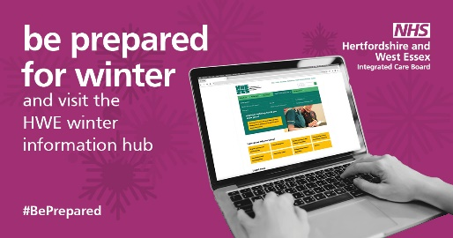
Your one-stop resource for staying healthy this winter!  Winter is just around the corner, and we are here to help you stay safe and well. Visit the Hertfordshire and west Essex winter health and wellbeing hub for the latest updates, advice, and resources on how to protect yourself and your loved ones during the colder months.  - Get information on flu, COVID-19, and RSV vaccinations  - Learn how to stock your medicine cupboard  - Find mental health support and advice  - Boost your immunity with simple tips  - Discover how to prevent falls  Everything you need is in one place. Check it out now at https://www.hertsandwestessex.ics.nhs.uk/winter  #BePrepared |  | A person typing on a laptop with the NHS Hertfordshire and west Essex website open. The screen displays the 'Winter Health Hub' section. Text on the image says, 'Be prepared for winter and visit the HWE (Hertfordshire and west Essex) winter information hub.' The background is magenta with snowflake designs.
Over 65? Protect yourself this winter by getting your flu jab. It is free and vital for your health.  The flu can lead to serious complications, but you can reduce the risk by getting vaccinated. Talk to your GP or pharmacist today.  https://www.hertsandwestessex.ics.nhs.uk/your-health-and-care/vaccinations/  #BePrepared | 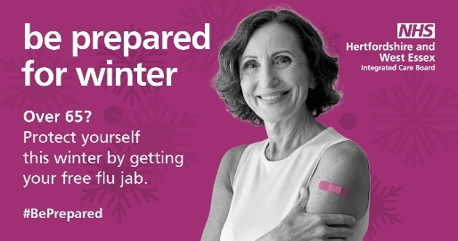 | NHS Hertfordshire and west Essex logo in the top right corner  A greyscale photo of a woman with short wavey hair, smiling at the camera, with a pink plaster on her upper arm.  Text reads: “be prepared for winter.  Over 65? Protect yourself this winter by getting your free flu jab.  #BePrepared”
Living with a long-term illness?  A flu jab can protect you from serious complications, including those from respiratory and kidney diseases.  Do not wait until it is too late. Get vaccinated today and stay protected.  https://www.hertsandwestessex.ics.nhs.uk/your-health-and-care/vaccinations/  #BePrepared | 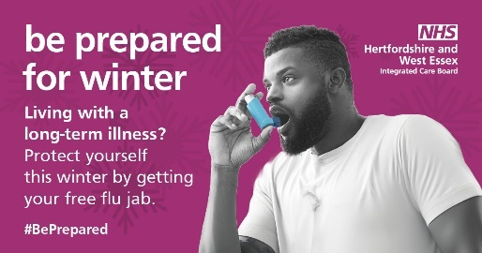 | NHS Hertfordshire and west Essex logo in the top right corner  A greyscale photo of a man taking a puff from his blue asthma pump.  Text reads: “be prepared for winter.  Living with a long-term illness?  Protect yourself this winter by getting your free flu jab.  #BePrepared”
Pregnant? Getting a flu jab is one of the best ways to protect both you and your baby from flu-related complications.  The vaccine is safe and recommended during pregnancy. Book your appointment now and ensure a healthy winter.  https://www.hertsandwestessex.ics.nhs.uk/your-health-and-care/vaccinations/flu-vaccines/  #BePrepared | 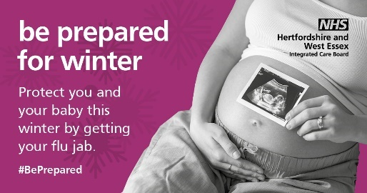 | NHS Hertfordshire and west Essex logo in the top right corner  A greyscale photo of a pregnant body, with an ultrasound photo held in front of the tummy.  Text reads: “be prepared for winter.  Protect you and your baby this winter.  #BePrepared”
Caring for someone vulnerable? Make sure both of you get the flu jab to stay protected this winter.  The flu can have serious effects on those with weakened immune systems. Protect yourself and those you care for by getting vaccinated.  https://www.hertsandwestessex.ics.nhs.uk/your-health-and-care/vaccinations/flu-vaccines/  #BePrepared | 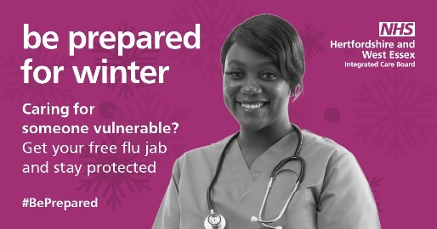 | NHS Hertfordshire and west Essex logo in the top right corner  A greyscale of a female doctor with short hair, smiling at the camera.  She is wearing scrubs and has a stethoscope round her neck.  Text reads: “be prepared for winter.  Caring for someone vulnerable?  Get your free flu jab and stay protected.  #BePrepared”
Weakened immune system? A flu jab can help protect you from severe flu complications.  Whether due to illness or medication, if your immune system is compromised, the flu vaccine is especially important for you.  Get vaccinated this winter.  https://www.hertsandwestessex.ics.nhs.uk/your-health-and-care/vaccinations/flu-vaccines/  #BePrepared | 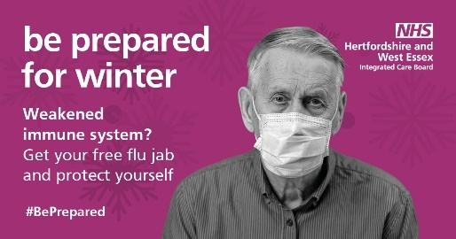 | NHS Hertfordshire and west Essex logo in the top right corner  A greyscale photo of an elderly gentleman wearing a shirt and a face mask.  Text reads: “be prepared for winter.  Weakened immune system?  Get your free flu jab and protect yourself.  #BePrepared”
Living with kidney disease? Protect yourself from flu complications by getting your flu jab.  Kidney disease can make you more vulnerable to the flu. Stay safe and healthy by ensuring you get your flu vaccine this winter.  https://www.hertsandwestessex.ics.nhs.uk/your-health-and-care/vaccinations/flu-vaccines/  #BePrepared | 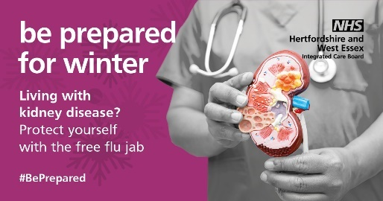 | NHS Hertfordshire and west Essex logo in the top right corner  A greyscale photo of a person wearing scrubs, holding a model of a kidney.  Text reads: “be prepared for winter.  Living with kidney disease?  Protect yourself with the free flu jab.  #BePrepared”
Living with heart disease? Protect yourself from flu complications by getting your flu jab.  Kidney disease can make you more vulnerable to the flu. Stay safe and healthy by ensuring you get your flu vaccine this winter.  https://www.hertsandwestessex.ics.nhs.uk/your-health-and-care/vaccinations/flu-vaccines/  #BePrepared | 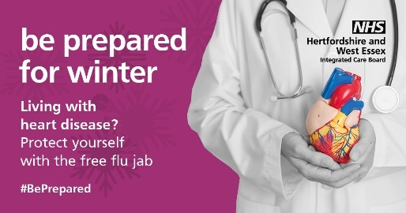 | NHS Hertfordshire and west Essex logo in the top right corner  A greyscale photo of a person wearing scrubs, holding a model of a heart.  Text reads: “be prepared for winter.  Living with heart disease?  Protect yourself with the free flu jab.  #BePrepared”
Look after your mental wellbeing.  Winter can be challenging for mental health. Take time to relax, practice mindfulness, and connect with loved ones.  Simple actions like talking to a friend or taking a few moments to meditate can make a significant difference.  https://www.hertsandwestessex.ics.nhs.uk/wintermental-health-winter/  #DoYourBitEssex #BePrepared | 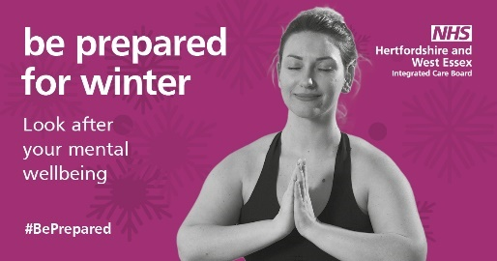 | NHS Hertfordshire and west Essex logo in the top right corner  A greyscale photo of a lady meditating.  Text reads: “be prepared for winter.  Look after your mental wellbeing.  #BePrepared”
Keep active this winter!  Regular exercise not only boosts your immunity but also lifts your mood.  Whether it is a brisk walk, a home workout, or joining a local class, staying active is key to a healthier winter.  https://www.hertsandwestessex.ics.nhs.uk/winterkeeping-active/  #BePrepared | 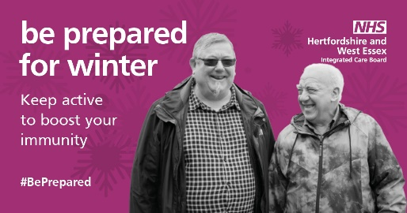 | NHS Hertfordshire and west Essex logo in the top right corner  A greyscale photo of two men out for a walk.  Text reads: “be prepared for winter.  Keep active to boost your immunity.  #BePrepared”
Eat well this winter!  Nourish your body with healthy foods to stay strong and healthy. Include a variety of fruits, vegetables, and whole grains in your diet.  Eating well helps support your immune system and overall wellbeing.  https://www.hertsandwestessex.ics.nhs.uk/winter  #BePrepared | 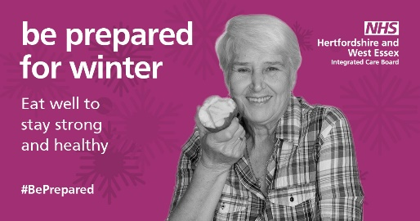 | NHS Hertfordshire and west Essex logo in the top right corner  A greyscale photo of a woman eating an apple.  Text reads: “be prepared for winter.  Eat well to stay strong and healthy.  #BePrepared”
Stock up your medicine cupboard!  Ensure you have all the essentials to handle minor ailments like colds, coughs, and headaches.  Having a well-stocked medicine cupboard means you can treat symptoms early and avoid unnecessary trips out in severe weather.  https://www.hertsandwestessex.ics.nhs.uk/winterkeeping-a-well-stocked-medicine-cupboard/  #BePrepared | 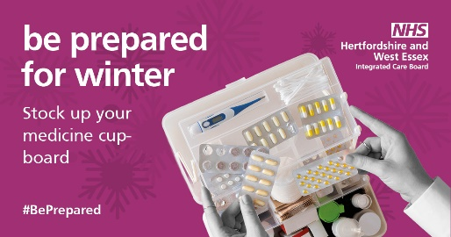 | NHS Hertfordshire and west Essex logo in the top right corner  A photo of a medicine box, which contains a thermometer and tablets.  Text reads: “be prepared for winter.  Stock up your medicine cupboard.  #BePrepared”
Use your pharmacy for advice!  Your community pharmacist should be your first port of call and can provide valuable health advice and help you manage minor ailments. They are a great resource for medication advice and general health tips, saving you a trip to the GP practice.  https://www.midandsouthessex.ics.nhs.uk/health/support/local-pharmacy-information/  #BePrepared | 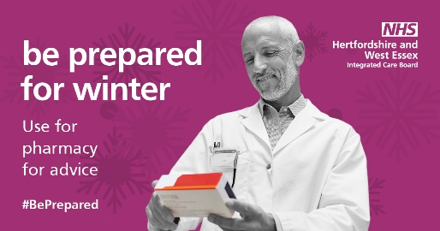 | NHS Hertfordshire and west Essex logo in the top right corner.  A greyscale photo of a male pharmacist reading a box of medicine.  Text reads: “be prepared for winter.  Use your pharmacy for advice.  #BePrepared”
Stay hydrated! Drinking water is essential for your health, even in winter.  Staying hydrated helps maintain your energy levels and supports your immune system. Remember to drink plenty of water throughout the day.  https://www.hertsandwestessex.ics.nhs.uk/winter  #BePrepared | 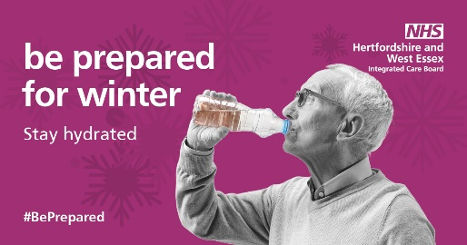 | NHS Hertfordshire and west Essex logo in the top right corner.  A greyscale photo of an elderly gentleman drinking from a bottle of water.  Text reads: “be prepared for winter.  Stay hydrated.  #BePrepared”
Check on your neighbours!  A friendly visit or a quick phone call can make a big difference, especially for those who may feel isolated during the winter months.  Let us look out for each other and ensure everyone stays safe and healthy.  https://www.hertsandwestessex.ics.nhs.uk/winterother-people/  #BePrepared | 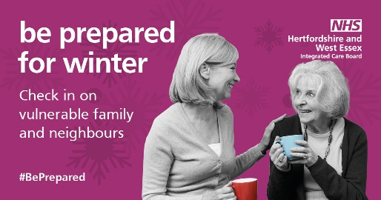 | NHS Hertfordshire and west Essex logo in the top right corner.  A greyscale photo of a woman and an elderly lady sitting together, drinking cups of tea, talking, and smiling.  Text reads: “be prepared for winter.  Check in on vulnerable family and neighbours.  #BePrepared.”

Be Prepared carousel posts for Instagram
Instagram does not support links within posts, but you can use a free tool like LinkTree to create a page of links that can be added to your Instagram bio. By including the HWE winter health hub on your LinkTree page, you can add a line at the bottom of each post that says, 'See link in bio for more information’

Content | Image suggestion
Flu vaccination is crucial!  Swipe through to see who should get their flu jab this winter. ➡️  #BePrepared | 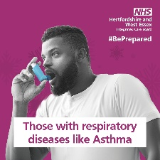  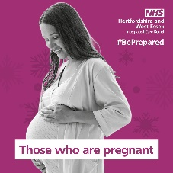  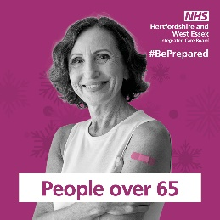  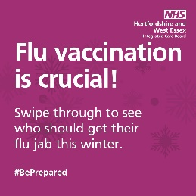  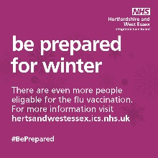  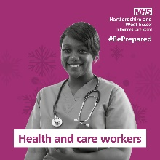
Winter Wellness Tips!  Swipe left to discover simple ways to stay healthy this winter ➡️  #BePrepared | 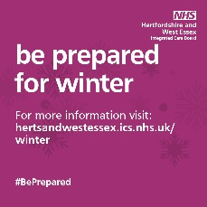  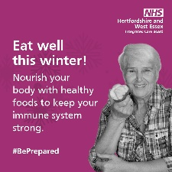  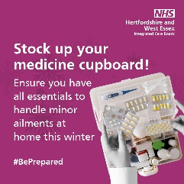  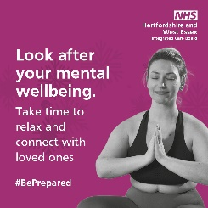  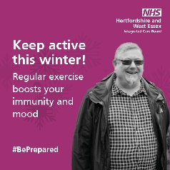  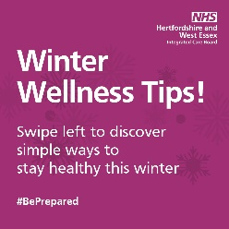
Stay Healthy This Winter!  Swipe through for essential tips. ➡️  #BePrepared | 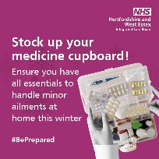  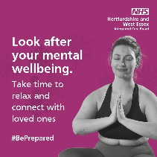  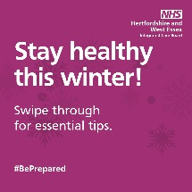  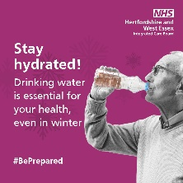  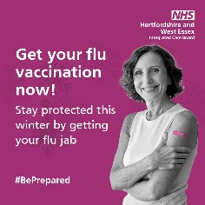  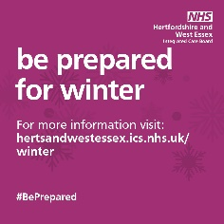  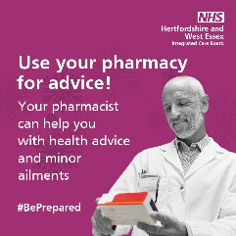  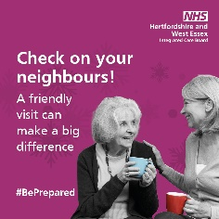

Social posts for RSV vaccination
Other communication assets for the RSV vaccination campaign can be downloaded from the DHSC (Department of Health and Social Care) (Department of Health and Social Care) campaign resource centre.
Post copy | Image | Alt text
Respiratory syncytial virus (RSV) can cause lung infections like bronchiolitis, making it difficult for newborn babies to breathe and causing 20,000 infants to need hospital treatment each year.  If you are pregnant our maternity immunisation team will contact, you at 24 weeks to book your vaccination in for when you are 28 weeks. If you have questions about the vaccination, please speak to your maternity team.  https://www.nhs.uk/conditions/respiratory-syncytial-virus-rsv/  #BePrepared | 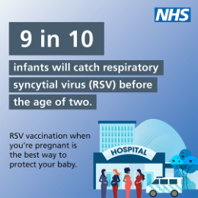  Download graphic | An illustration of a hospital with pregnant women stood outside. Text reads: 9 in 10 infants will catch respiratory syncytial virus (RSV before the age of two. Speak with your maternity service or GP to get your free vaccine.
People aged 75-79 can get a free vaccination to protect themselves from respiratory syncytial virus (RSV), a common lung infection that can lead to serious illnesses like pneumonia.  Read more about RSV vaccination here: https://www.nhs.uk/conditions/respiratory-syncytial-virus-rsv/  #BePrepared | 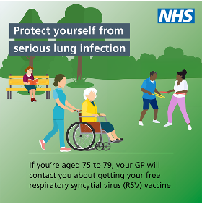  Download graphic | An illustration of older people doing activities in a park. Text reads: Protect yourself from serious lung infection. If you are aged between 75-79, your GP will contact you about getting your free respiratory syncytial virus (RSV) vaccine.
Pregnant women are eligible for a free respiratory syncytial virus (RSV) vaccine to protect their babies from serious lung infections.  You can get your vaccine from 28 weeks of pregnancy. Talk to your GP or maternity service to schedule yours.  Read more: https://www.nhs.uk/conditions/respiratory-syncytial-virus-rsv/  #BePrepared | 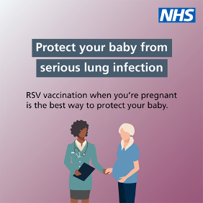  Download graphic | An illustration of a pregnant women talking to a health care professional. Text reads: Protect your baby from serious lung infection. If you are at least 28 weeks pregnant, speak to your maternity service or GP about getting your RSV vaccination.

National Resources

Further national resources can be found on the Campaign Resource Centre
- RSV vaccination
- Childhood vaccinations
- Get Vaccinated Get Winter Strong

Where possible, when using these assets, please still link back to the Hertfordshire and west Essex winter information hub. This will ensure our communities receive local information.
The national toolkit for Pharmacy First is being updated and is due to be release in November.

Evaluation and feedback
We encourage all partners to share feedback on the effectiveness of the campaign in their communities. Regular updates and insights can help us refine our approach and improve future initiatives
Please email Gemma McKelvey, Senior Communications and Engagement Manager at gemma.mckelvey@nhs.net if you have any questions about the campaign, discuss ways in which you can support and to share evaluation and feedback metrics.

